|  |  |  |
| --- | --- | --- |
| Лабораторная работа №3  Физическое проектирование БД | Ф.И.О. | Мельников В. Д. |
| Группа | ИВТ-264 |
| Преподаватель | Аль-Мерри Гаис Мохаммед Салех |
| Дата сдачи | 21.03.2025 |

Реализация собственной БД

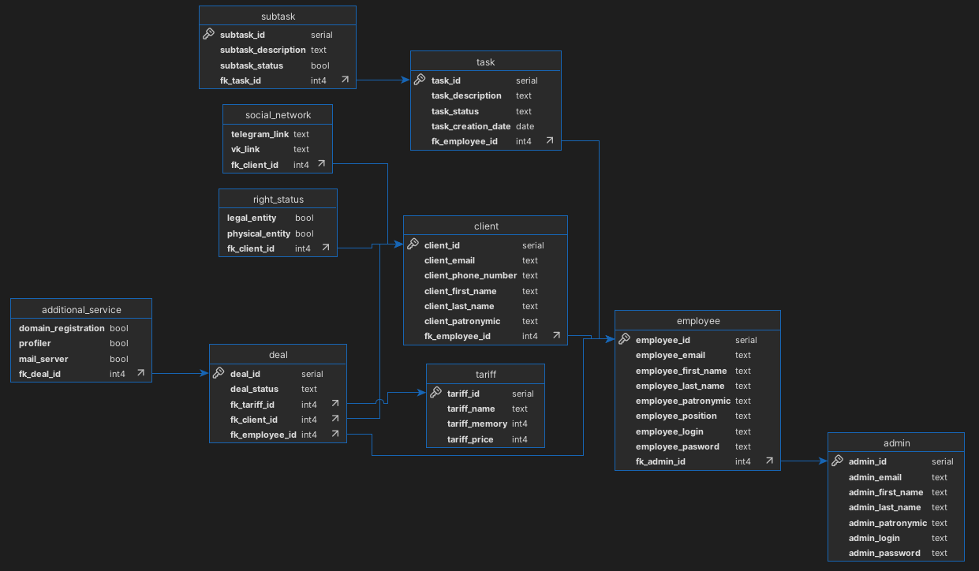

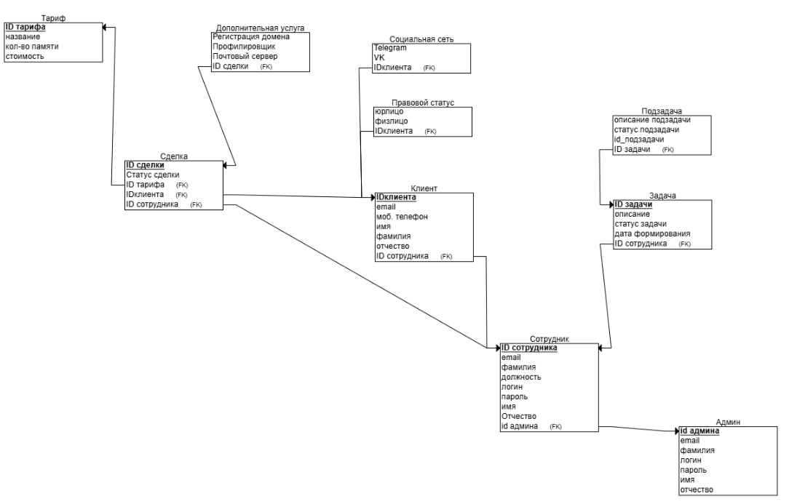

Скриншоты наполненных таблиц

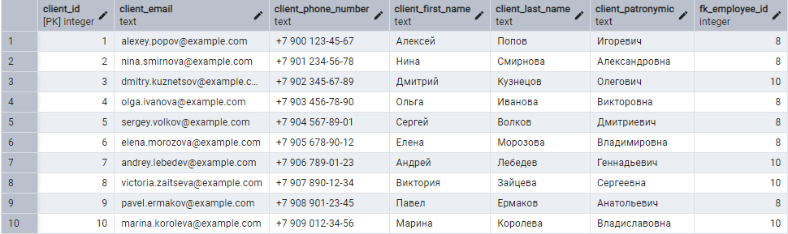

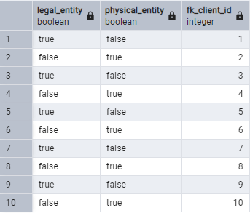

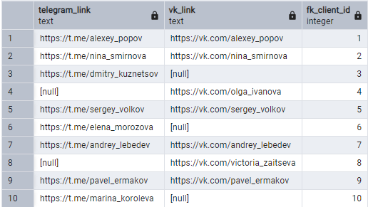

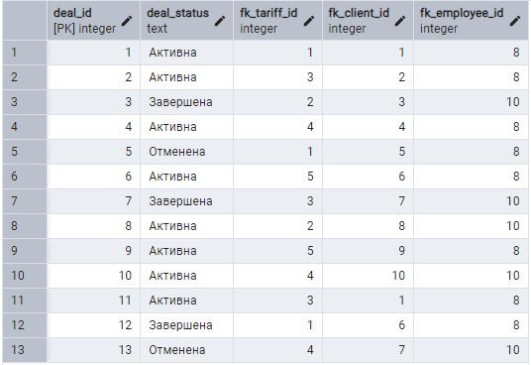

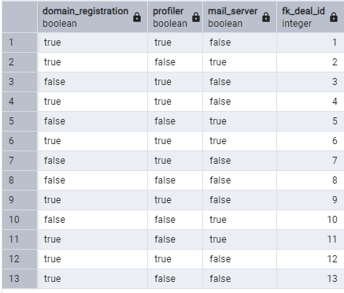

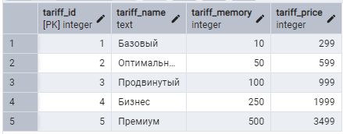

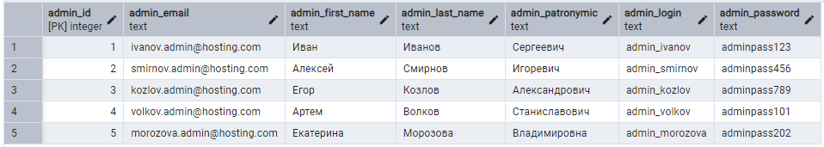

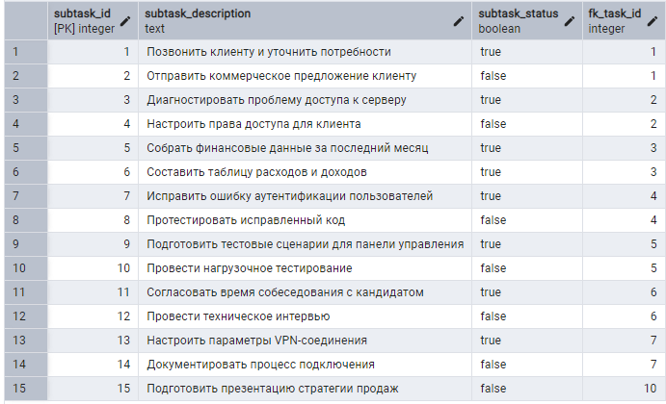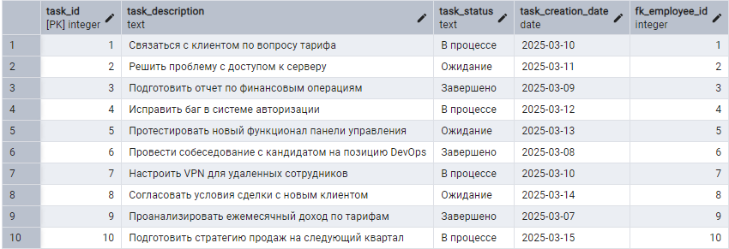

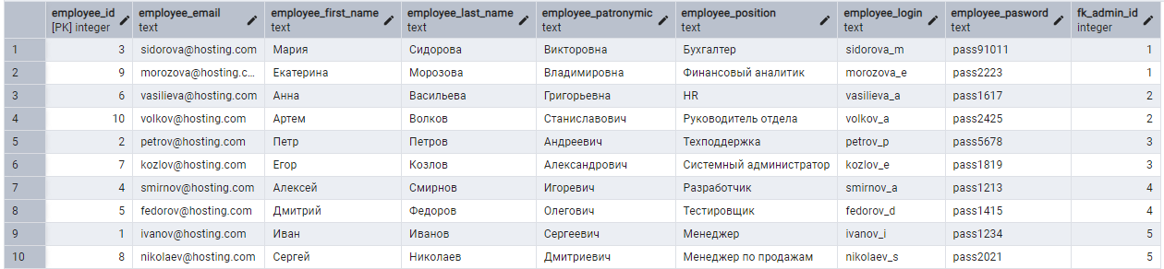

Реализация БД одногруппника

Реляционная схема одногруппника

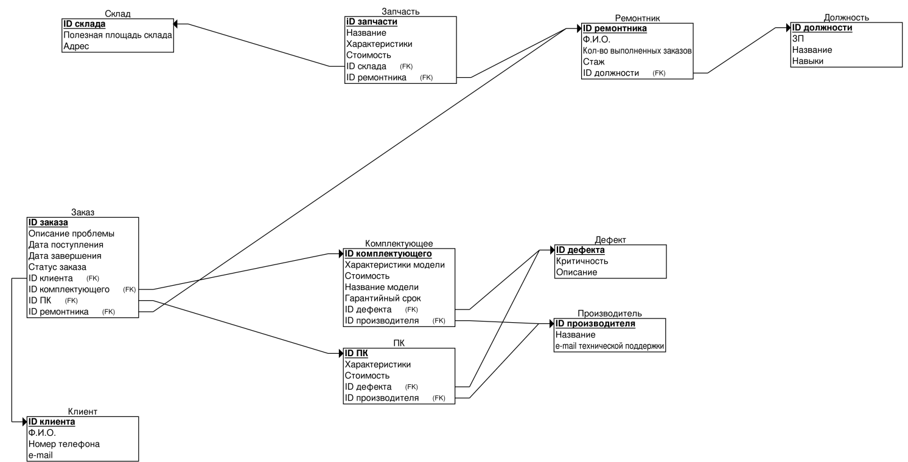

Реляционная схема, сгенерированная на основе созданной БД

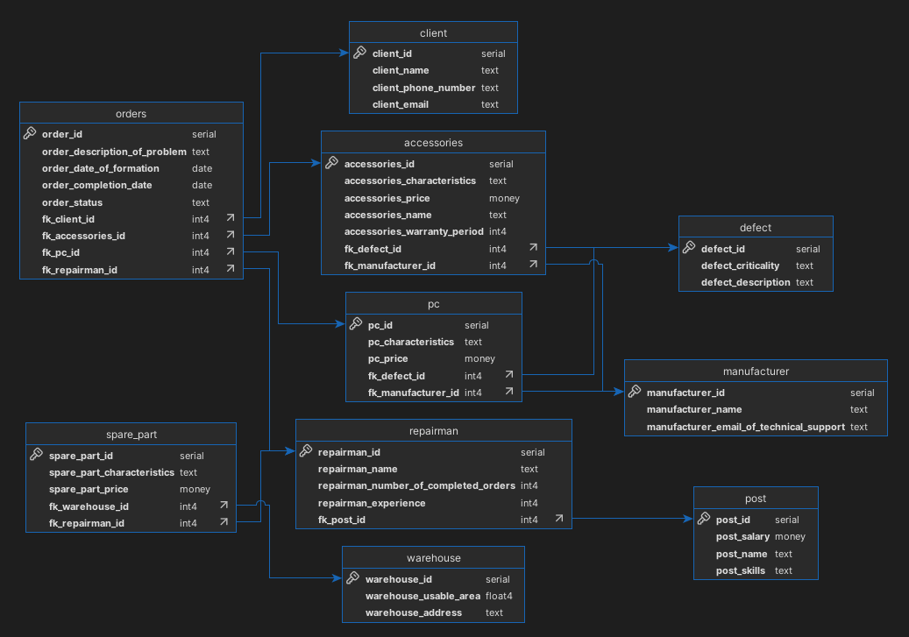

Текст написанных SQL-скриптов и скриншот результата их работы

CREATE DATABASE polyakov;

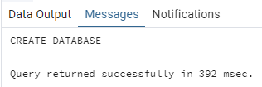

CREATE TABLE warehouse (

warehouse_id SERIAL PRIMARY KEY,

warehouse_usable_area REAL NOT NULL,

warehouse_address TEXT NOT NULL

);

CREATE TABLE post (

post_id SERIAL PRIMARY KEY,

post_salary MONEY NOT NULL,

post_name TEXT NOT NULL,

post_skills TEXT NOT NULL

);

CREATE TABLE repairman (

repairman_id SERIAL PRIMARY KEY,

repairman_name TEXT NOT NULL,

repairman_number_of_completed_orders INT DEFAULT 0,

repairman_experience INT DEFAULT 0,

fk_post_id INT REFERENCES post (post_id)

);

CREATE TABLE spare_part (

spare_part_id SERIAL PRIMARY KEY,

spare_part_characteristics TEXT NOT NULL,

spare_part_price MONEY NOT NULL,

fk_warehouse_id INT REFERENCES warehouse (warehouse_id),

fk_repairman_id INT REFERENCES repairman (repairman_id)

);

CREATE TABLE client (

client_id SERIAL PRIMARY KEY,

client_name TEXT NOT NULL,

client_phone_number TEXT NOT NULL,

client_email TEXT

);

CREATE TABLE defect (

defect_id SERIAL PRIMARY KEY,

defect_criticality TEXT NOT NULL,

defect_description TEXT NOT NULL

);

CREATE TABLE manufacturer (

manufacturer_id SERIAL PRIMARY KEY,

manufacturer_name TEXT NOT NULL,

manufacturer_email_of_technical_support TEXT NOT NULL

);

CREATE TABLE PC (

PC_id SERIAL PRIMARY KEY,

PC_characteristics TEXT NOT NULL,

PC_price MONEY NOT NULL,

fk_defect_id INT REFERENCES defect (defect_id),

fk_manufacturer_id INT REFERENCES manufacturer (manufacturer_id)

);

CREATE TABLE accessories (

accessories_id SERIAL PRIMARY KEY,

accessories_characteristics TEXT NOT NULL,

accessories_price MONEY NOT NULL,

accessories_name TEXT NOT NULL,

accessories_warranty_period INT NOT NULL,

fk_defect_id INT REFERENCES defect (defect_id),

fk_manufacturer_id INT REFERENCES manufacturer (manufacturer_id)

);

CREATE TABLE orders (

order_id SERIAL PRIMARY KEY,

order_description_of_problem TEXT NOT NULL,

order_date_of_formation DATE NOT NULL,

order_completion_date DATE,

order_status TEXT NOT NULL,

fk_client_id INT REFERENCES client (client_id),

fk_accessories_id INT REFERENCES accessories (accessories_id),

fk_PC_id INT REFERENCES PC (PC_id),

fk_repairman_id INT REFERENCES repairman (repairman_id)

);

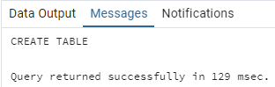

INSERT INTO post (post_id, post_salary, post_name, post_skills)

VALUES (1, 3000, 'Мастер по ремонту', 'Ремонт ПК, замена комплектующих');

INSERT INTO repairman (repairman_id, repairman_name, repairman_number_of_completed_orders, repairman_experience, fk_post_id)

VALUES (1, 'Петр Петров', 50, 5, 1);

INSERT INTO client (client_id, client_name, client_phone_number, client_email)

VALUES (1, 'Иван Иванов', '+79123456789', 'ivan.ivanov@example.com');

INSERT INTO manufacturer (manufacturer_id, manufacturer_name, manufacturer_email_of_technical_support)

VALUES (1, 'TechCorp', 'support@techcorp.com');

INSERT INTO defect (defect_id, defect_criticality, defect_description)

VALUES (1, 'Высокая', 'Неисправность материнской платы');

INSERT INTO accessories (accessories_id, accessories_characteristics, accessories_price, accessories_name, accessories_warranty_period, fk_defect_id, fk_manufacturer_id)

VALUES (1, '16 ГБ DDR4', 100.00, 'Оперативная память', 24, 1, 1);

INSERT INTO PC (PC_id, PC_characteristics, PC_price, fk_defect_id, fk_manufacturer_id)

VALUES (1, 'Intel i7, 16 ГБ RAM, 1 ТБ SSD', 1200.00, 1, 1);

INSERT INTO orders (order_description_of_problem, order_date_of_formation, order_status, fk_client_id, fk_accessories_id, fk_PC_id, fk_repairman_id)

VALUES ('Не включается', '2023-10-01', 'В процессе', 1, 1, 1, 1);

INSERT INTO warehouse (warehouse_usable_area, warehouse_address)

VALUES (500.5, 'ул. Складская, 123');

INSERT INTO spare_part (spare_part_characteristics, spare_part_price, fk_warehouse_id, fk_repairman_id)

VALUES ('Жесткий диск 1 ТБ', 50.00, 1, 1);

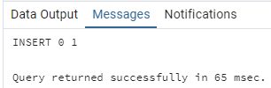

ALTER TABLE repairman ADD COLUMN repairman_email TEXT;

ALTER TABLE repairman ADD COLUMN repairman_phone_number TEXT;

ALTER TABLE client ADD COLUMN client_last_name TEXT;

ALTER TABLE orders DROP COLUMN order_completion_date;

ALTER TABLE accessories DROP COLUMN accessories_warranty_period;

ALTER TABLE orders ADD FOREIGN KEY (fk_pc_id) REFERENCES pc (pc_id);

ALTER TABLE post DROP COLUMN post_skills;

ALTER TABLE repairman ADD UNIQUE (repairman_phone_number);

ALTER TABLE client ADD UNIQUE (client_email);

ALTER TABLE repairman ADD UNIQUE (repairman_email);

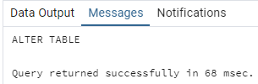

ALTER TABLE repairman RENAME TO employee;

ALTER TABLE orders RENAME COLUMN order_description_of_problem TO order_description;

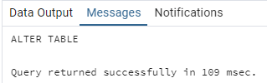

DROP TABLE client CASCADE;

DROP TABLE orders CASCADE;

DROP TABLE pc CASCADE;

DROP TABLE defect CASCADE;

DROP TABLE post CASCADE;

DROP TABLE warehouse CASCADE;

DROP TABLE spare_part CASCADE;

DROP TABLE employee CASCADE;

DROP TABLE manufacturer CASCADE;

DROP TABLE accessories CASCADE;

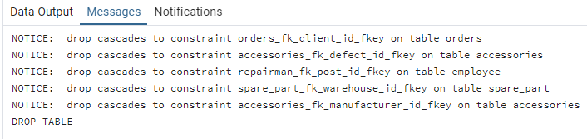

DROP DATABASE polyakov;

